**11.Container with Most Water**

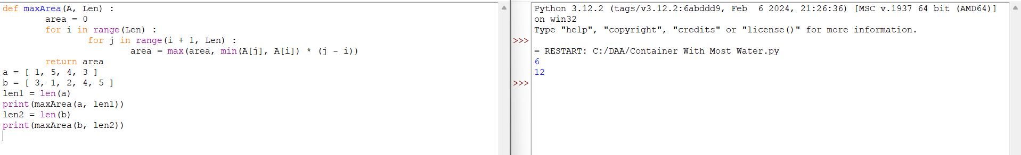

**12.Integer to Roman**

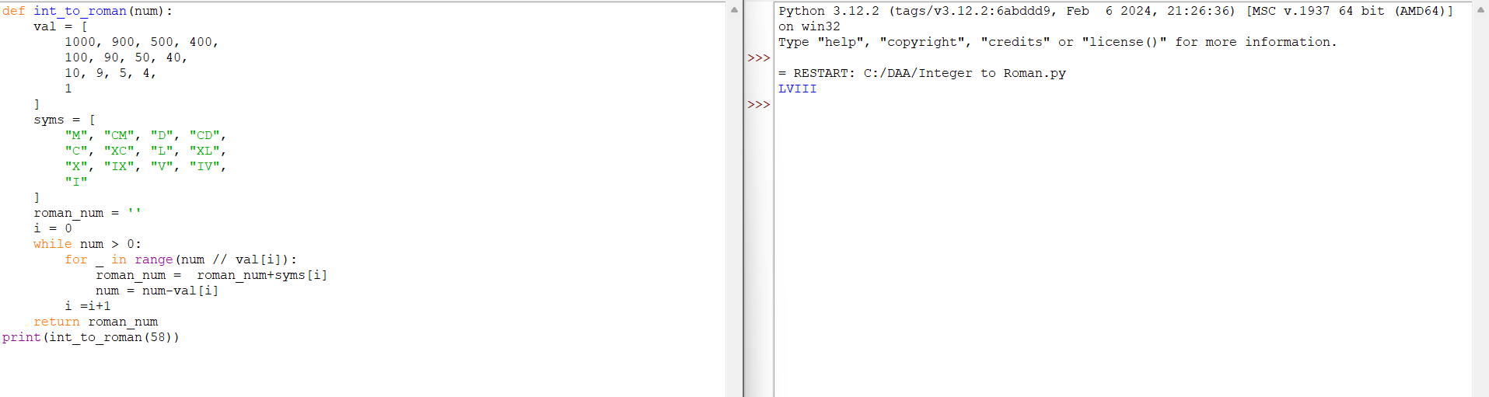

**13.Roman to Integer**

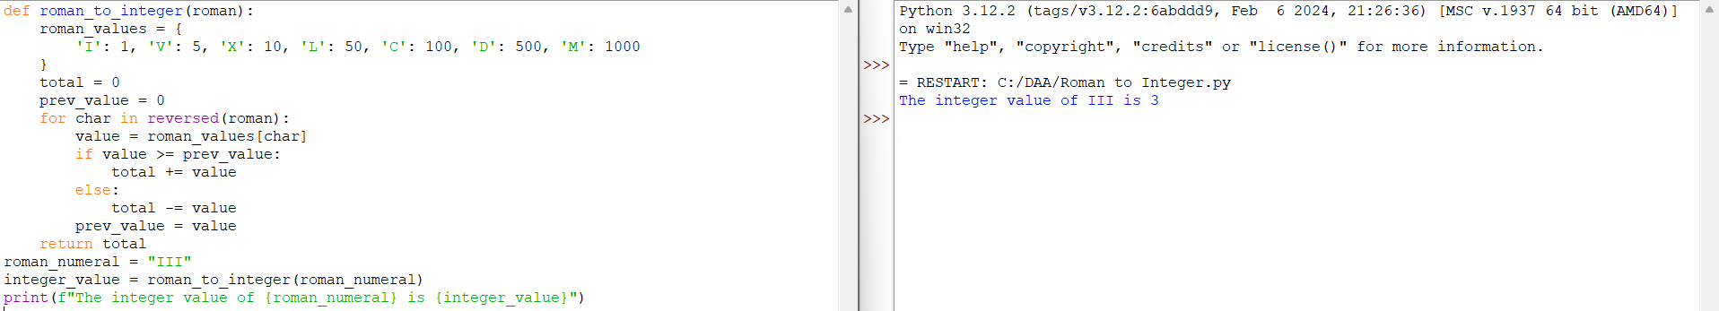

**14.Longest Common Prefix**

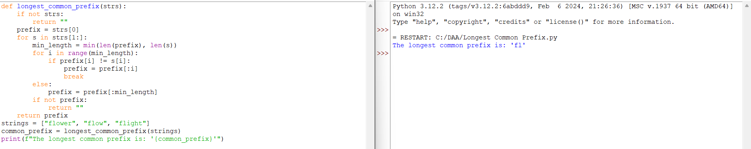

**15.3Sum**

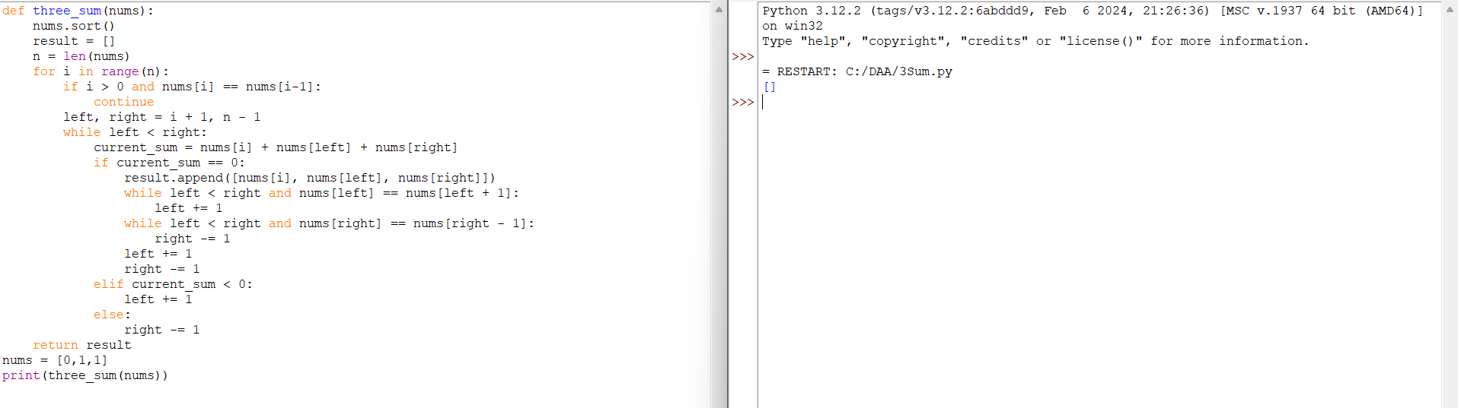

**16.3Sum Closest**

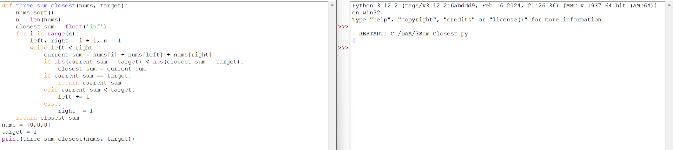

**17.Letter Combinations of a phone Number**

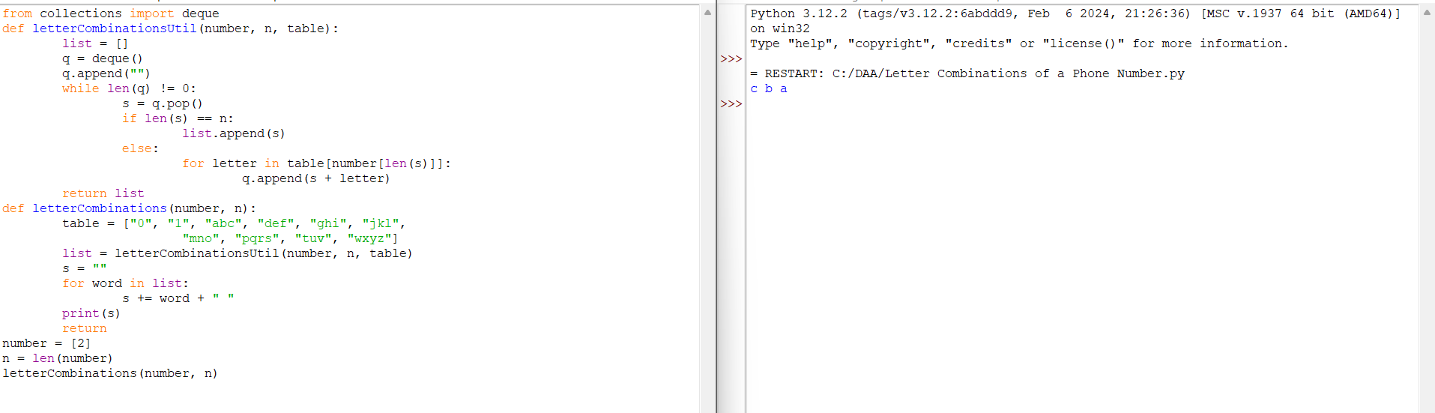

**18.4Sum**

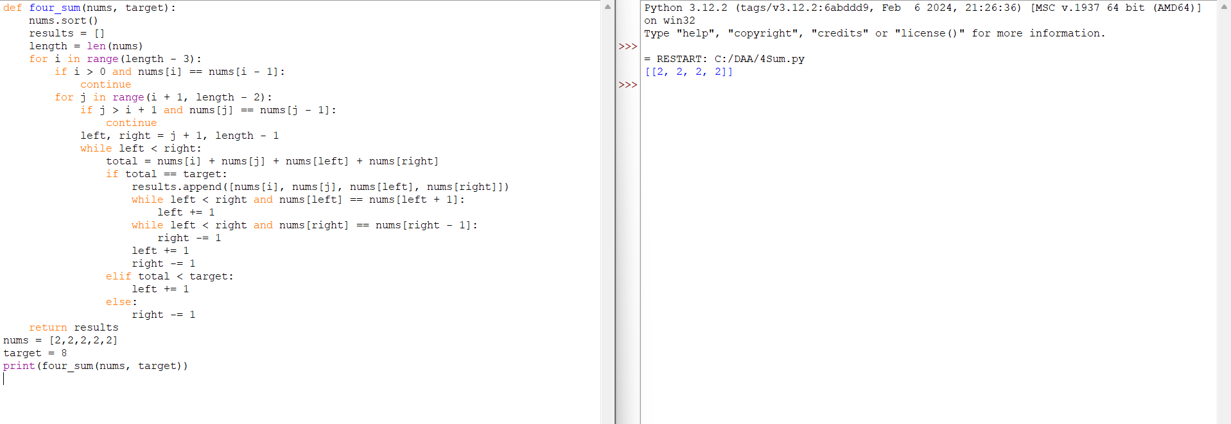

**19.Remove Nth Node from End of List**

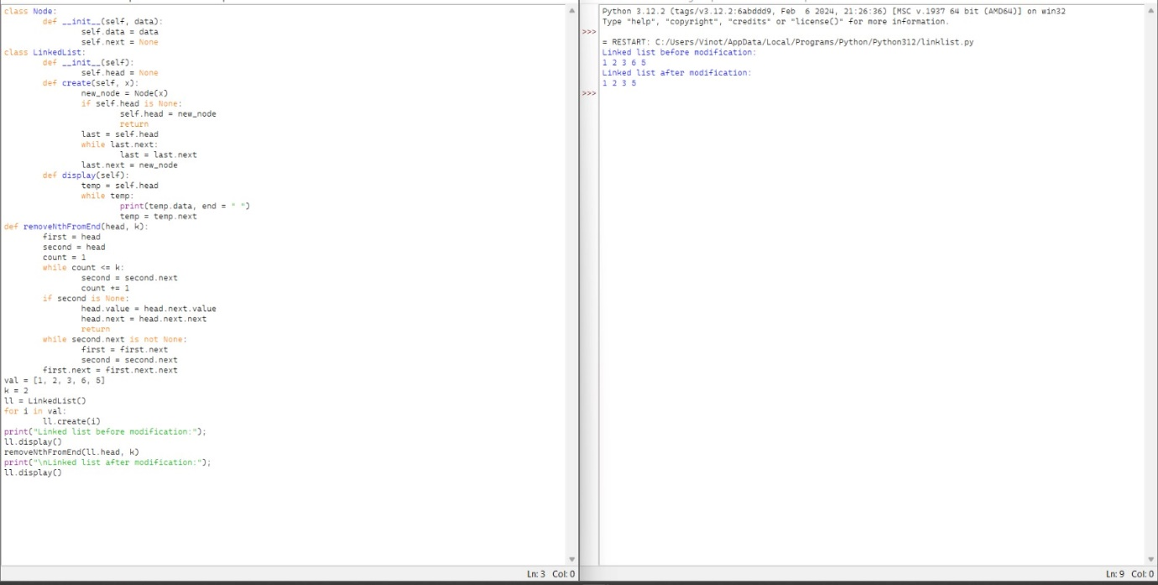

**20.Valid Parentheses**

